 | Sanjivani Rural Educational Society’s  SANJIVANI COLLEGE OF ENGINEERING  (An Autonomous Institution)  Kopargaon – 423 603, Maharashtra. | ACAD-F-15 K
Academic Year: 2025-26 | CIA CASE STUDY ACTIVITY ABSTRACT | ISO Revision : 00  ISO Dated: 1/Jan/2024
Department : | COMPUTER ENGINEERING | Date of Preparation:
Course Code & Name: | Digital Electronics & Logic Design – (MDCO221) | Year/Sem: SY(A) SEM-1 W’26

Group ID: 5
Title: : “Minimal MUX: Adder and Subtractor”

Roll No | PRN No | Name of the Student | Mobile No. | Email | Signature
16 | 0124UCSM1016 | Sarwadnya P. Maile | 9022979996 | sarwadnyam@gmail.com
17 | 0124UCSM1017 | Piyush B. Pawar | 9021235684 | Piyushpawar172@gmail.com
18 | 0124UCSM1018 | Shreyash S. Gage | 7972904911 | Shreyash.age@gmail.com
19 | 0124UCSF1019 | Tanishka A. Autade | 7584858181 | Tanishka.Autade@gmail.com
20 | 0124UCSM1020 | Gregory R. Marak | 6009638761 | Gregorymarak@gmail.com

Date of Submission :

Course Coordinator Prof. P.M. Dhanrao

1. Aim

The aim of this project is to design and implement an Adder and Subtractor circuit using minimal multiplexers. The focus is to demonstrate how multiplexers can be used to perform arithmetic operations efficiently while minimizing hardware components.

2. Abstract

This report presents the design and working of a minimal MUX-based Adder and Subtractor circuit. By using 2:1 and 4:1 multiplexers, both addition and subtraction operations can be achieved within the same logic structure. The design minimizes gate usage and demonstrates how multiplexers can serve as universal combinational logic elements
Introduction
Digital circuits often rely on adders and subtractors for arithmetic operations. Traditionally, these circuits are implemented using logic gates such as XOR, AND, and OR. However, multiplexers can replicate the same functions with reduced component count. This experiment explores how a MUX can be configured to perform full-adder and subtractor functions, making circuit design more compact and versatileA Multiplexer is like an intelligent traffic controller for digital signals. It takes several input signals and, based on the values of selection lines, allows only one of them to pass through to the output at any given time. This not only reduces the number of required hardware connections but also makes the entire system faster and more organized.
For example, imagine a situation where multiple sensors are providing data to a microcontroller. Instead of connecting each sensor separately with a dedicated input pin, a multiplexer can be used to select and transmit data from any one sensor at a time, saving resources and simplifying the design.
The beauty of multiplexers lies in their simplicity and scalability. Starting from a basic 2-to-1 MUX, we can expand the design to 4-to-1, 8-to-1, or even larger configurations by adding more selection lines. Each configuration helps engineers manage complex data-handling tasks with fewer components, making multiplexers an essential part of computer architecture, communication systems, and control circuits.
In this report, we explore the design and working principles of 4-to-1 and 8-to-1 multiplexers, understand how they are built using logic gates, and analyze their truth tables, Boolean expressions, and practical applications in modern electronic systems.

4. Theory of Operation
A multiplexer can implement any Boolean function, including arithmetic operations. The Full Adder produces a Sum and Carry output based on three inputs (A, B, Cin), while a Full Subtractor produces Difference and Borrow outputs. Both outputs can be expressed in Boolean form and mapped into MUX truth tables. For example, a 4:1 MUX can realize Sum = A ⊕ B ⊕ Cin, and Carry = AB + BCin + ACin, by assigning input combinations appropriately

5. Architecture and Logic Diagram
- The minimal MUX design uses a 4:1 MUX for each output (Sum/Difference and Carry/Borrow). The select lines are derived from two of the inputs, while the MUX data inputs are assigned based on the third input’s Boolean effect. The implementation demonstrates that with proper mapping, both addition and subtraction can be performed using fewer logic gates.

5.4 Hierarchical Design
Larger multiplexers can be constructed from smaller ones.
For example:
- An 8-to-1 MUX can be built using two 4-to-1 MUXes and one 2-to-1 MUX.
- The 4:1 MUXes handle lower-level input selection, while the 2:1 MUX acts as a higher-level selector to choose between their outputs.
This modular architecture reduces complexity and improves flexibility in digital system design.

6. Features of Multiplexers
A Multiplexer (MUX) is a compact and efficient digital device designed to route multiple input signals through a single output line.
Its main features that make it valuable in modern digital systems are:

1. Efficient Data Selection
A multiplexer selects one input from several and transmits it to the output, reducing the need for multiple data lines and simplifying circuit design.

2. Hardware Optimization
By using logic gates instead of multiple switches or wires, multiplexers minimize hardware requirements, making circuits smaller and more cost-effective.

3. Scalability
Multiplexers can easily be expanded from 2:1 to 4:1, 8:1, or higher configurations by adding more selection lines, offering flexibility in design.

4. High-Speed Operation
Built with fast-switching logic gates, multiplexers provide quick data transfer and are ideal for high-speed digital systems.

Truth Table
The truth table for the full adder and subtractor implemented using MUX is constructed using combinations of A, B, and Cin (or Bin). For each combination, MUX selection inputs determine which data line is activated to produce the desired output.
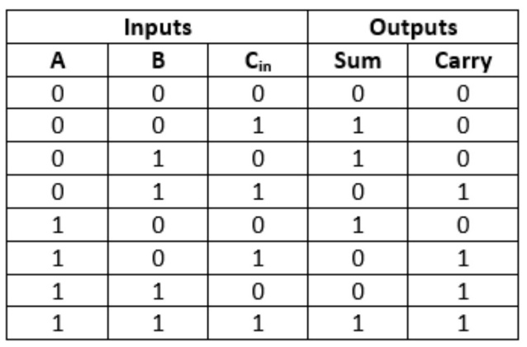 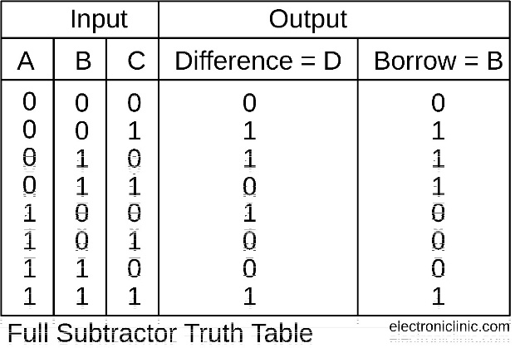

8. Features and Applications
Features: Compact design, reduced hardware, reconfigurable for both addition and subtraction, high-speed digital operation.
Applications: Arithmetic Logic Units (ALUs), digital processors, and embedded systems where space and speed are critical.

Conclusion
Multiplexers, both 4-to-1 and 8-to-1, are fundamental building blocks in digital electronics that simplify data selection and routing. They allow multiple input signals to share a single output line, reducing circuit complexity and hardware requirements.
Through this project, we explored the design, truth tables, Boolean expressions, and working of multiplexers. The study highlighted how 4:1 and 8:1 MUXs can be implemented using basic logic gates, as well as how larger multiplexers can be constructed hierarchically from smaller ones.
Multiplexers are widely used in computers, communication systems, signal processing, memory addressing, and control systems, demonstrating their versatility and importance in modern electronics. Their scalability, efficiency, and compact design make them a vital component in both simple and complex digital circuits.
Overall, multiplexers ensure reliable, fast, and efficient data handling, forming the backbone of many digital and communication systems.

References
- Tocci, R. J., Widmer, N. S., & Moss, G. L. (2025). Digital Systems: Principles and Applications. Pearson Prentice Hall.
- Mano, M. M. (2025). Digital Logic and Computer Design. Pearson Education.
- Stallings, W. (2025). Computer Organization and Architecture: Designing for Performance. Pearson.
- Floyd, T. L. (2025). Digital Fundamentals. Pearson.

